

**Semester Project**

**Data Structures and Algorithms**

**(ES-221)**

**Muhammad Sohaib Abdullah (2023520)**

**Saad Afridi (2023617)**

1. **Project Title & Problem Statement**

**Title: Train Reservation System**

Managing train reservations efficiently is a crucial task, requiring quick modifications, deletions, and searches. This system will store passengers' data in a doubly linked list, allowing smooth traversal (both forward and backward) and easy modifications, such as adding, removing, or updating reservations.

**2. Data Structures Selection**

* **Doubly Linked List**: Used to store passengers' booking details, allowing efficient insertion, deletion, and traversal in both directions.
* **Queue**: Can be used for a waiting list feature if all seats are booked.

**3. Algorithmic Approach**

* **Insertion Algorithm**: Add new passengers at the correct position in the linked list.
* **Deletion Algorithm**: Remove passengers who cancel their booking.
* **Traversal Algorithm**: Navigate forward and backward to search for reservations.
* **Modification Algorithm**: Update passenger details like seat number or travel date.
* **Sorting Algorithm**: Sort bookings based on departure time or seat number.

**4. Input & Output Design**

* **Input:** 
  + Passenger name, train number, departure date, seat number, and ticket ID.
  + Option to modify or cancel a reservation.
* **Processing:** 
  + Insert new bookings into the doubly linked list.
  + Traverse and search for a booking.
  + Modify or delete a booking if needed.
* **Output:** 
  + Display passenger details and booking confirmation.
  + Show available and booked seats.

**6. Course Concepts Application**

This project applies key Data Structures and Algorithms concepts

* **Doubly Linked List**: For efficient addition, deletion, and traversal of bookings.
* **Queue:** To handle a waiting list system
* **Sorting & Searching Algorithms**: To manage and retrieve passenger details efficiently
* **Dynamic Memory Allocation**: To optimize storage and retrieval operations dynamically

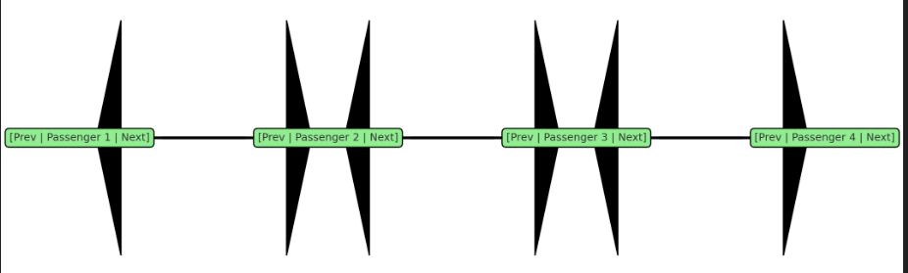

**Fig:1.1Doubly linked list diagram for Train Reservation System.**